# INTRODUCTION

* 1. Overview
* Before the iPhone, browsing the internet on a mobile phone was a clunky and frustrating experience.
* The iPhone changed that with its Safari browser, and made mobile web browsing a smooth & enjoyable experience.
* This was a big deal, as it paved the way for the mobile-first internet we know today.
* The Apple I marked the beginning of a new era in personal computing, where technology became more accessible to everyday users. It inspired other companies and entrepreneurs to follow in its footsteps and develop innovative products that would help to shape the future of technology.
* “iPhone is a revolutionary and magical product that is literally five years ahead of any other mobile phone,"
  1. Purpose
* iPhone, series of smartphones produced by Apple Inc., combining mobile telephone, digital camera, music player, and personal computing technologies.
* It's not just inescapable connectivity that the iPhone helped bring about. It's also how we access the internet. The iPhone made mobile web browsing useful for the first time. Soon came a flood of apps, which removed the need to open a web browser at all, and opened a whole new world for the user.
* Another big part of having an iPhone is the App Store. There are millions of great iPhone apps for students on the App Store right now that are excellent tools to help students with their studies, whether that's a study aid or just an overall general planner.

1. **Problem Definition & Design Thinking**
   1. Empathy Map

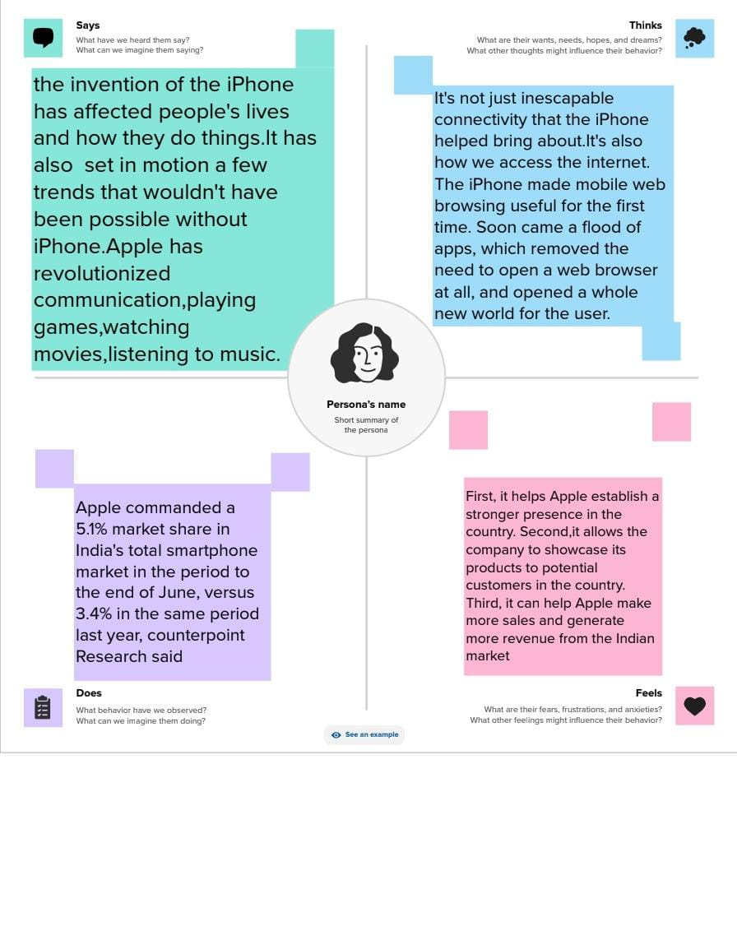

* 1. Ideation & Brainstorming Map

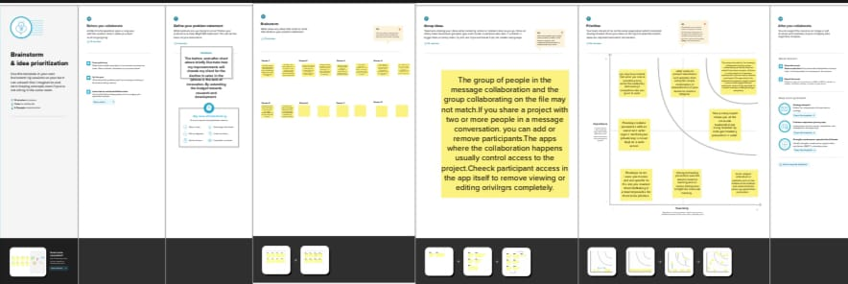

# RESULT

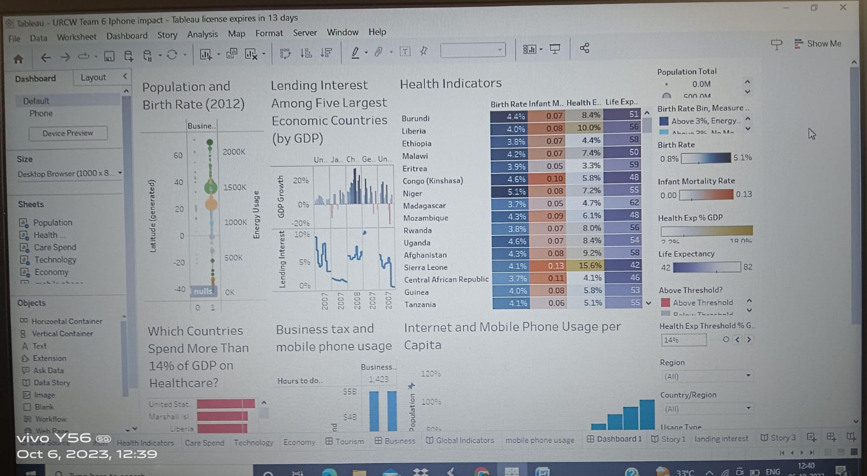

# ADVANTAGES

* The iPhone has many advantages. For which users do not want to shift to other brands of devices.Notable among these are long time software update facility, security, eye-catching design, performance. Below are some more features and benefits of the iPhone was highlighted..
* The iPhone is an ideal phone to use if you own other Apple products, such as Mac computers, iPads and iPods. With Apple's free iCloud service, the iPhone shares data, music, photos and contacts with all your other Apple products. It's an added convenience that takes the hassle out of transferring data between products.
* The iPhone camera is so advanced that many people are doing away with their digital cameras and using their iPhone exclusively for picture-taking purposes. IPhone 5 features an 8-megapixel iSight camera that offers 40 percent faster photo-taking than previous models and also offers a panorama feature, which allows users to snap 240-degree panorama photos that are 28 megapixels in resolution. The iSight camera records video in 1080p high definition.

**DISADVANTAGES**

* Despite its dominance in the space of mobile devices and computing, the company does face some key challenges. Among these weaknesses are its highly-priced products, entering areas of higher competition, and incompatibility with other software.
* There are also downsides to iPhone. These include the fact that on average, the iPhone has a lower quality of battery life than Android. Another con of getting an iPhone is the low storage due to the absence of a micro SD card. iPhones are also pretty expensive and not customizable.
* The iPhone battery life is not that great when compared to other smartphones. While many people will be happy with the performance of their batteries, especially if it lasts all day long, some may find this a problem for them.
* Usually, you can find out how much battery your phone has left by looking at the percentage in the top right corner of your screen. If you see it going down quickly and don't have a charger nearby, then maybe consider getting an external backup power supply so you never run out again.

# APPLICATIONS

* The iPhone's innovative hardware and software features, its commitment to user privacy and security. And its impact on the development of the App Store and other digital marketplaces has made it the standard-bearer in the smartphone industry.
* The App Store is what made the iPhone a must-have device. There are now more than 2 million apps in the App Store, with essentially every company making one or more apps. And the iPhone and App Store have spawned industries that couldn't exist without smartphones.

# CONCLUSION

* Apple Inc. has a long development history. And with the long-term growth, it has achieved a certain successful development. The various strategies have contributed much to the rapid and successful development.
* Overall, Apple's marketing strategies have been successful in establishing the company as a market leader in the technology industry. The company's focus on product design, pricing, promotion, and distribution has enabled it to differentiate its products, build a strong brand image, and maintain profitability.

# FUTURE SCOPE

* But in the future, the most important part of the iPhone might be everything around it. That's according to analysts who've observed the mobile industry's general trends and Apple's strategy. In the short term, we're likely to see incremental improvements like higher quality cameras and giant displays.
* Apple's sales growth down across every region

In its own words, much of Apple's future success will depend on the company's continuing ability to “compete successfully, [which] depends heavily on ensuring the continuing and timely introduction of innovative new products, services and technologies to the marketplace”.

* It's anticipated that future iPhones might incorporate some of these advanced display technologies, such as mini-LED or micro-LED, to deliver stunning visuals in a compact form factor. These technologies offer higher brightness, better contrast ratios, and more power efficiency compared to traditional OLED screens.

# APPENDIX

A. Source Code



https://public.tableau.com/app/profile/shiny.evangelya.a/viz/URCWTeam6Iphoneimpact/Dashboard1?publish=yes